Requirements Workflow

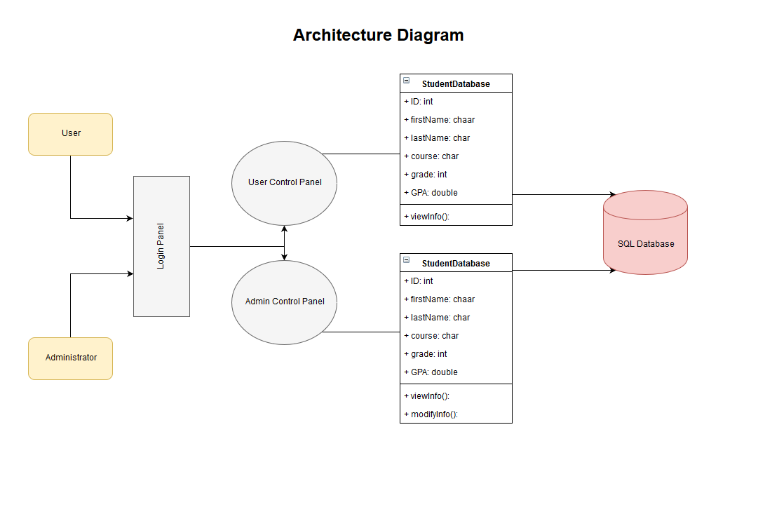

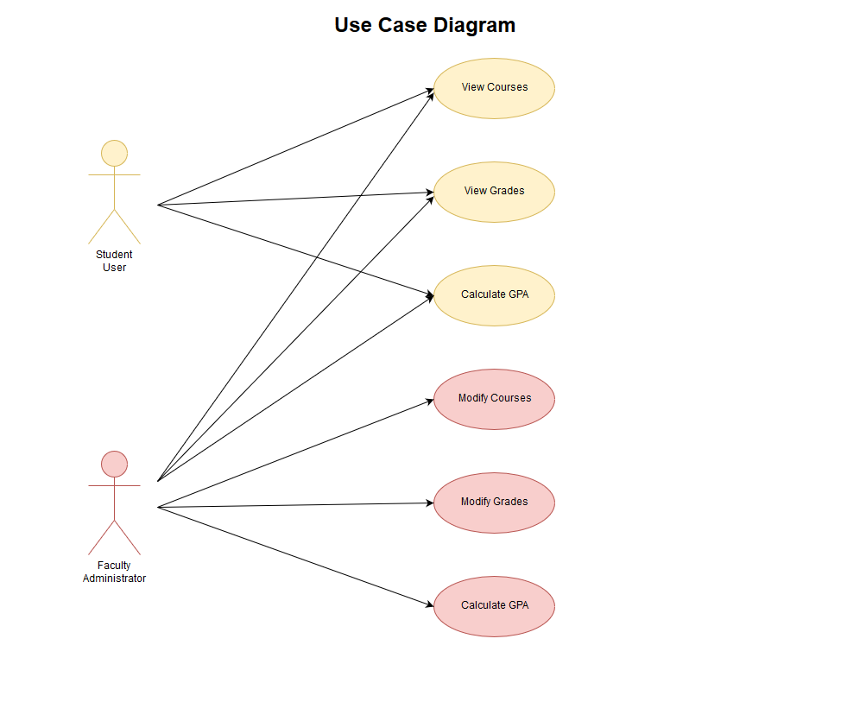

Business Case Document

EXECUTIVE SUMMARY

Business Case Summary

The current environment needs a method of allowing a student to electronically access their information such as their current courses, individual course grades, overall GPA, and other course information. Our desktop application intends on fixing these issues by serving this information to the students (Users) and allowing modification of these records to the faculty (Administrator).

Anticipated Outcomes

* Allow students to access their course information.
* Allow faculty to modify courses and grades for individual students.
* Allow viewing of information from any location.

Critical Success Factors

* Creating a viable database to store all student information.
* A secure login for faculty to prevent tampering of the data.
* A portal for administrators and users to login separately.

RECOMMENDED SOLUTION

Solution Overview

The recommended solution is to provide a desktop application to can access a centralized, secure server that’s hosted by the university or school system. The application will be used be either on campus or on the user’s preferable network. Grade and course updates will be updated nearly immediately for both the user and administrator.

Solution Benefits

This provides with easy access to course information and grades. Faculty have the added benefits of adjusting grades at any location that they choose.

IMPLEMENTATION DETAILS

Deliverables

|  |  |  |  |
| --- | --- | --- | --- |
| ID | Deliverable | Owner | Dependencies |
| 1 | Requirements and Initiation Artifacts | Alex | Deliverable #1 |
| 2 | Analysis Artifacts | Aissa | Deliverable #2 |
| 3 | Design Artifacts | Aissa | Deliverable #3 |
| 4 | Implementation Artifacts | Jonathan | Deliverable #4 |

Implementation Timeline

|  |  |  |
| --- | --- | --- |
| Project Phase | Target Begin Date | Target End Date |
| Planning | 09/01/2017 | 10/01/2017 |
| Execution | 10/02/2017 | 11/25/2017 |
| Go-Live/Implementation | 11/25/2017 | 11/27/2017 |
| Closing | 11/27/2017 | Submission |

CONCLUSIONS AND RECOMMENDATIONS

This project will need to be complete, functioning, and reliable by 11/27/17. A programming language and interface will need to be chosen based on compatibility with the chosen database. For this reason, we recommend the use of Visual Basic. It meets the requirements, ease of use, and all team member are relatively familiar with the language, concepts, and development environment. If any issues or complications occur, then this plan will be reevaluated and revised based on the type of issue.

Analysis Workflow

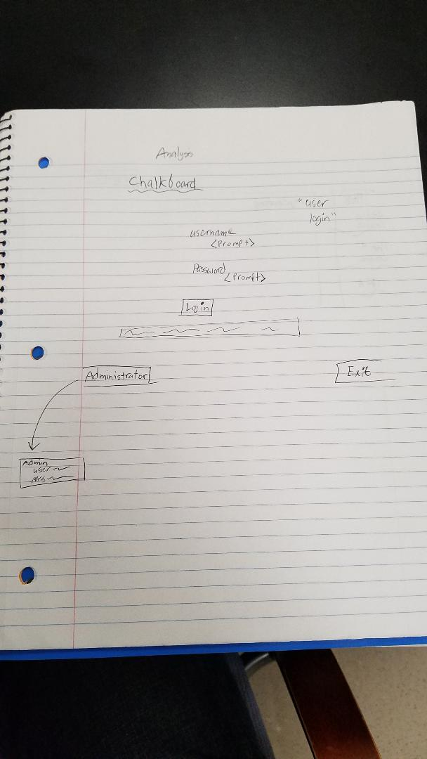

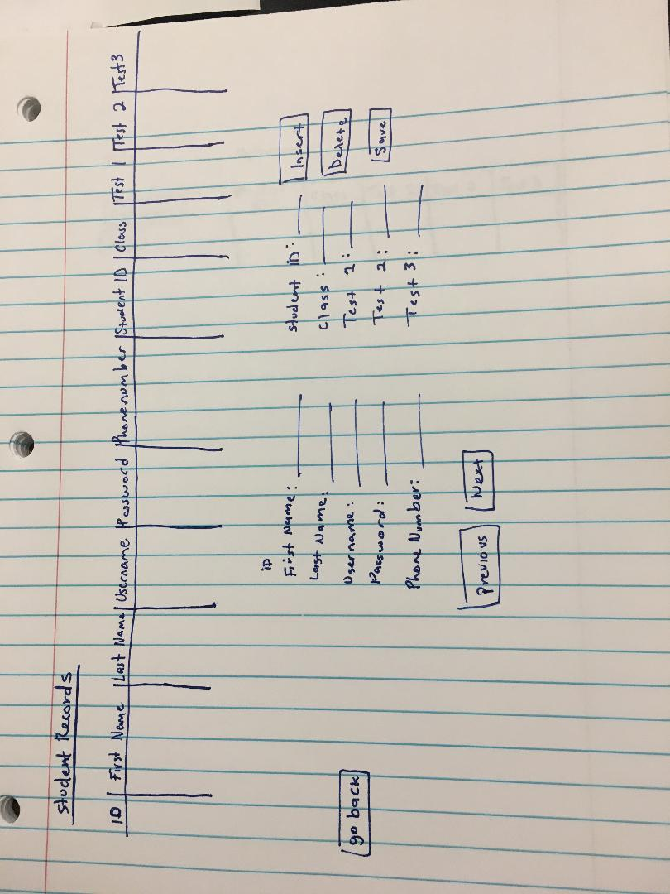Design Workflow

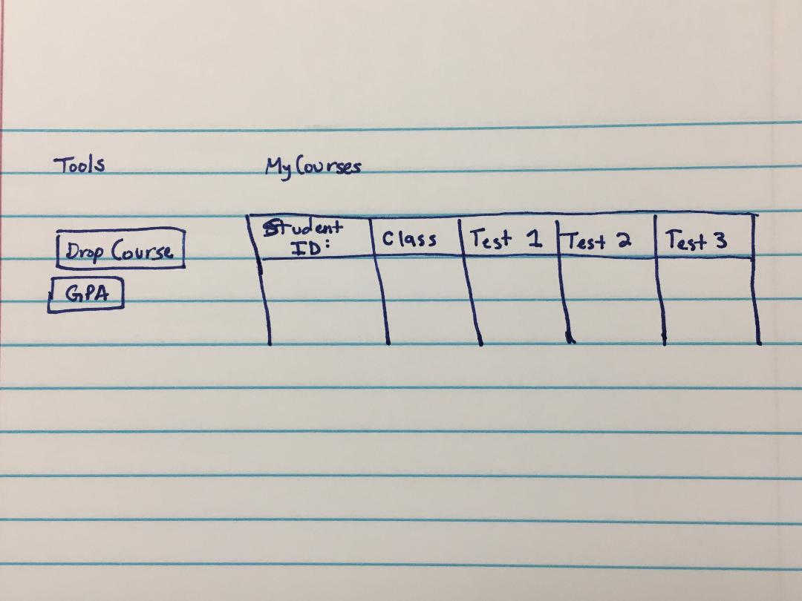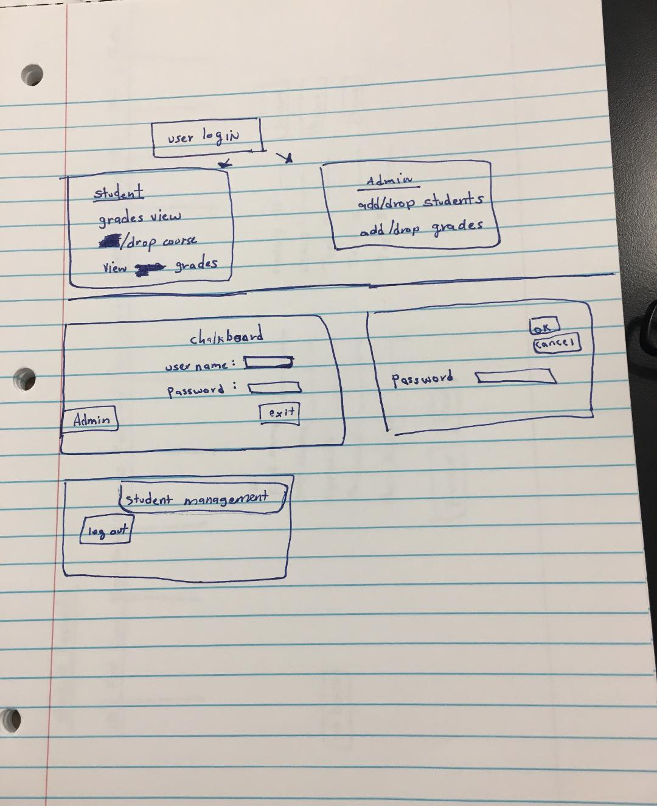

Implementation Workflow

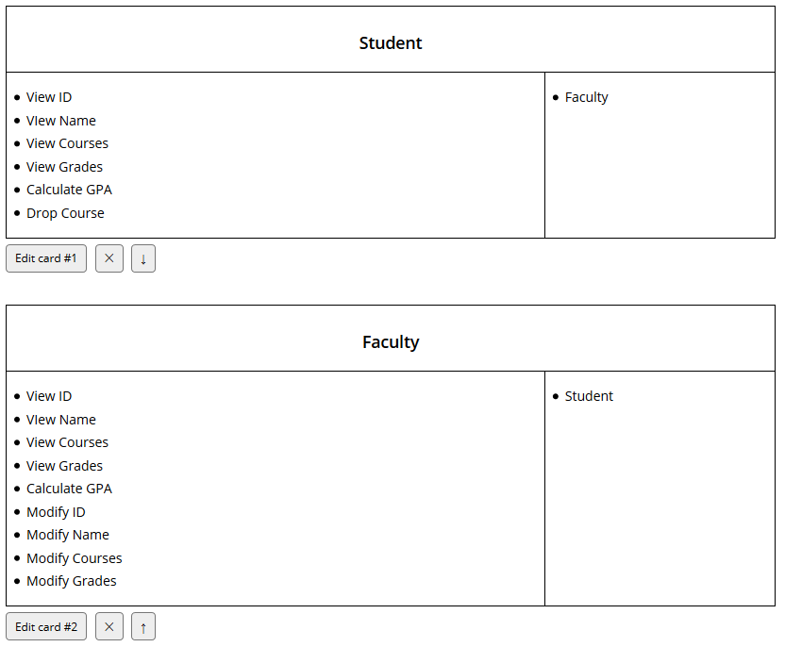

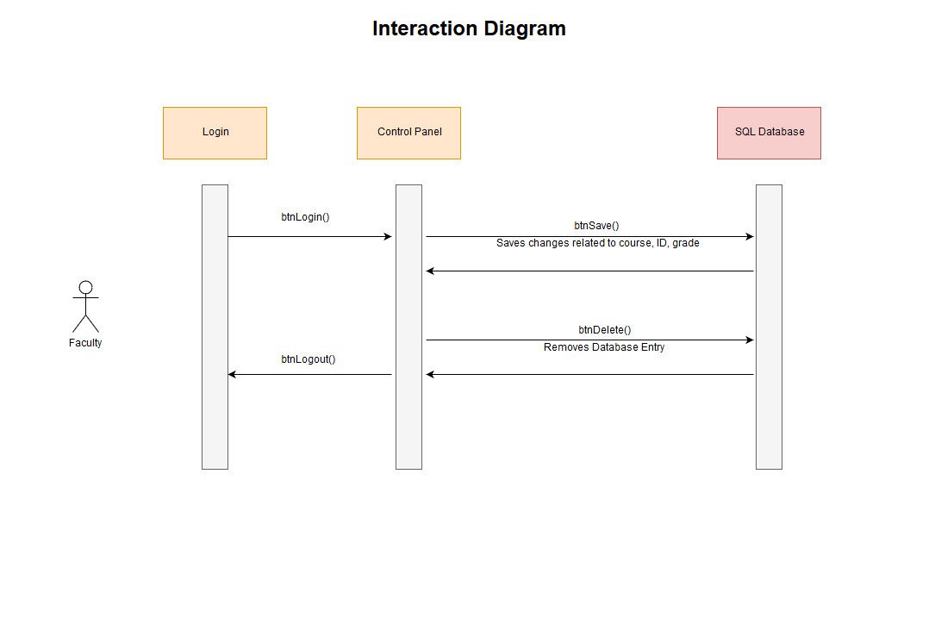

Testing Workflow